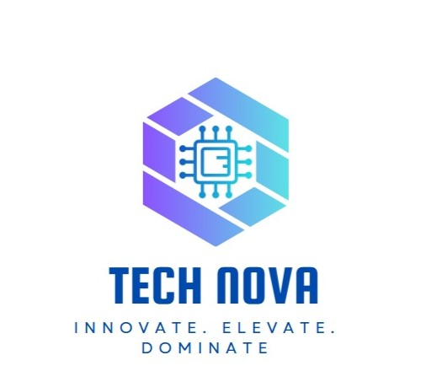

# Employee Engagement Template

# Employee Information

What is your job role?

Individual Contributor

Team Lead

Manager

Senior Manager

Regional Manager

Vice President

Management / C-Level

Partner

Owner

Volunteer

Intern

Other

What department do you work in?

Finance

IT

Human Resources

Operations

Testing

CRM

ERD

Customer Service

Did you feel a sense of belonging within the team and organization?

Yes. I feel welcomed and part of the team.

How would you rate the work environment and culture?

Positive. Open communication and mutual respect.

How would you describe the effectiveness of your immediate supervisor?

Supportive and encouraging. Provides room for growth.

Were your goals and expectations aligned with the organization’s vision?

Yes. Clear goals and alignment with the company’s direction.

Did you find the company’s policies and procedures fair and equitable?

Yes. The policies are well communicated and applied fairly.

How would you rate the organization’s support for maintaining a healthy work-life balance?

Good. The workload is manageable and respectful of personal time.

Were you satisfied with your salary and benefits package?

Yes. Fair compensation and consistent recognition.

Did you receive enough training and development opportunities?

Yes. Continuous learning is encouraged.

Did you experience burnout or excessive stress in your role?

No. The environment is supportive and paced appropriately.

Would you recommend this company as a good place to work?

Yes. The CRM department is a great place to work.

Do you find your daily tasks engaging and meaningful?

Yes. Tasks are challenging and fulfilling.

Do you feel recognized for your contributions and efforts?

Yes. Recognition is timely and meaningful.

Do you feel challenged in your role in a positive way?

Yes. I am learning and growing every day.

How would you rate the overall work environment in the IT department?

Excellent. The CRM department fosters **a collaborative, respectful, and inclusive culture.** Team members support one another, and communication is open and effective. As a CRM department

How comfortable do you feel reaching out for help when facing technical challenges?

Very comfortable. The team encourages **knowledge sharing**, and everyone is approachable when it comes to troubleshooting or sharing ideas.

Have you received sufficient training and development opportunities in the last year?

Yes. The department offers regular training sessions and supports attending external workshops or upskilling programs based on individual needs.

How would you describe your current workload?

Balanced and manageable. Tasks are well-organized and **distributed fairly**, allowing for productivity without burnout.

What improvements would you suggest to enhance employee engagement and job satisfaction?

1- Offer cross-departmental projects for broader exposure.

2- Add more personalized learning paths.

3- Schedule occasional team-building activities or offsites to strengthen morale.

Is leadership invested in and contributing to your culture initiatives?

Yes. Leadership is **actively involved and genuinely cares** about employee well-being. Managers take feedback seriously and continuously work on improving the environment.

Do you see yourself working here in a year?

Yes. The supportive culture, clear growth opportunities, and healthy work-life balance make CRM **a department worth staying in**

Does your work challenge you and aid your development?

Yes. Tasks are **dynamic and goal-driven**, offering new learning experiences and meaningful contributions to the company.

Do you have the tools needed to maximize your potential here?

Yes. The department ensures we have access to **up-to-date tools, systems, and resources** that help us perform at our best.

What motivates you to do your best work here?

1-A supportive and respectful team,

2-Recognition of contributions,

3- Alignment with the company’s goals,

• And the opportunity to **grow and learn continuously**.

What could we do better to support your career growth and development?

1-Continue providing learning and mentorship opportunities.

2-Explore career path mapping to help employees visualize their future in the company.

3-Encourage leadership development tracks for those interested in growing into managerial roles.